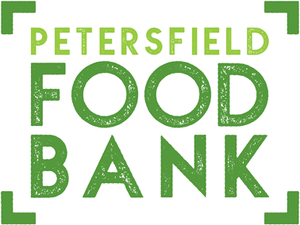

Petersfield Food Bank provides bags of food to families and individuals in difficulties, who are referred by various statutory and voluntary agencies working in the Petersfield area.

If you would like to make a donation, we are currently low on the following items:

Household cleaning spray
Men’s/women’s deodorant
Baby wipes
Nappies sizes 5/6/7
Tinned meat
Tinned tomatoes
Sweet extras – KitKats etc
Biscuits
Washing powder/liquid

WE ARE UNABLE TO TAKE FRESH OR FROZEN/CHILLED FOOD All items should be tinned, dried or packaged, and in-date

For further details about Petersfield Food Bank visit: pactfoodbank.org.uk

We have various collection points around Petersfield, including supermarkets, churches and some banks and building societies. Food is distributed from Petersfield Methodist Church on Tuesday and Friday mornings between 9.30 and 11.30. We are very grateful for all the donations that we receive.
If you would like our support, or are aware of anyone in need of our help, please let us know. You can email our manager at manager@pactfoodbank.org.uk or come to the Methodist Church on a Monday or Wednesday morning between 9.30 and 11.30.

Registered Charity CIO No. 1193002 APRIL 2024

